

Narrogin Senior High School
Examination, Semester Two, 2018

ATAR MODERN HISTORY
Unit 3 & 4

Document Set | Area of Study | Related Question
1 | Australia 1918–1955 | 1
2 | Russia and the Soviet Union 1914–1945 | 1
3 | China 1935–1989 | 1
4 | The changing European world since 1945 | 1
5 | Australia’s engagement with Asia | 1
6 | The struggle for peace in the Middle East | 1

DOCUMENT BOOKLET

Document Set 1: Australia 1918–1955

Source 1
(Hughes had a major influence on Australia’s external relations in the first half of the 20th century. His conduct of matters while in Paris attending the Peace Conference from January to June 1919 with Navy Minister Joseph Cook was the peak of this achievement.)

A French journalist described Hughes at Versailles in the following words:

….frail, narrow-shouldered, stooped, with the long, metallic face, seamed with lines, of a Breton peasant, at first he sits doubled up like a spider and lets others talk ... but suddenly he straightens out, darts forward his thin arms and the double trident of stretched out fingers and cuts through the flabbiness of the discussion with a word.

Source 2
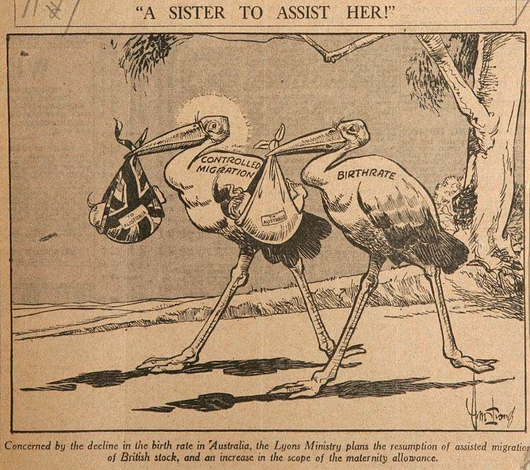
1937 - 'A sister to assist her'.

Source 3
(In 1949 Robert Menzies' Liberal-Country Party Coalition won government, championing the anti-Communist cause.[(NAA: A5954, 2315/13, p. 15])

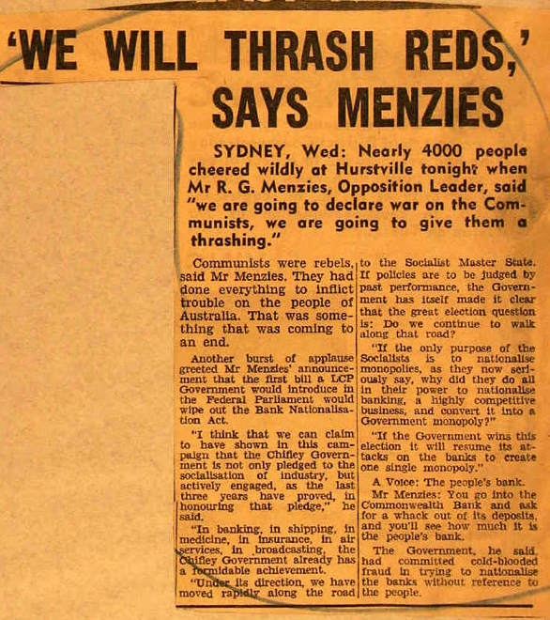

Source 4
(An extract from MILESTONES: 1945–1952 The Australia, New Zealand and United States Security Treaty (ANZUS Treaty), 1951 – US Department of State - 2016)

Australia initially considered the idea of a regional pact in the Pacific in the 1930s, and in 1946, at a meeting of the Commonwealth Prime Ministers, it suggested that the major powers of the British Commonwealth form a regional defense system. If such an organization were created, the members could then invite the United States and other countries with strong interests in the Pacific to join. At that time, however, the United States was not yet prepared to commit itself to formal security arrangements in the Pacific. During the late 1940s, the United States was heavily engaged in the rebuilding of Japan, but the United States did not extend its defense interests far beyond Japanese territory before the Korean War. In response to Australian suggestions for a regional coalition, U.S. Secretary of State Dean Acheson stated that formal treaties with the South Pacific nations were unnecessary, as any real attack on Australia or New Zealand would elicit a U.S. response even without formal treaties in place to guarantee it. Moreover, the situations in the Atlantic and the Pacific were quite different, so there was no question of simply creating a “Pacific Treaty Organization” to parallel NATO. The Pacific Ocean was much larger, and the nations that bordered it were far more culturally and linguistically diverse than the nations of the North Atlantic. Other considerations led the United States to hesitate to commit to a regional organization in the Pacific as well. A number of the countries in Southeast Asia were still under colonial rule, or in the process of developing as independent states, and therefore neither they nor their colonial governments were in a position to make regional security commitments. At this time, the United States was also faced with the critical situation in Europe, including the occupation and support of West Germany and West Berlin and facing what it saw as the Soviet threat on that continent. There were fewer immediate economic or political threats to force equal attention to the security of the Southwest Pacific.

END OF DOCUMENT SET

Document Set 2: Russia and the Soviet Union 1914–1945
Source 1
(An extract from J. V. Stalin -SPEECH DELIVERED AT A PLENUM OF THE CENTRAL COMMITTEE AND THECENTRAL CONTROL COMMISSION OF THE R.C.P.(B.) January 17, 1925
J. Stalin, Trotskyism, Moscow, 1925- On the Opposition, Foreign Languages Press, Peking, 1974
pp. 183-87).
Comrades, on the instructions of the Secretariat of the Central Committee I have to give you certain necessary information on matters concerning the discussion and on the resolutions connected with the discussion. Unfortunately, we shall have to discuss Trotsky's action in his absence because, as we have been informed today, he will be unable to attend the plenum owing to illness. You know, comrades, that the discussion started with Trotsky's action, the publication of his The Lessons of October.
The discussion was started by Trotsky. The discussion was forced on the Party.
The Party replied to Trotsky's action by making two main charges. Firstly, that Trotsky is trying to revise Leninism; secondly, that Trotsky is trying to bring about a radical change in the Party leadership.

Trotsky has not said anything in his own defence about these charges made by the Party.
It is hard to say why he has not said anything in his own defence. The usual explanation is that he has fallen ill and has not been able to say anything in his own defence. But that is not the Party's fault, of course. It is not the Party's fault if Trotsky begins to get a high temperature after every attack he makes upon the Party.
Source 2
(Bolshevik Cartoon on the Intervention of the USA, Britain and France in the Russian Civil War, 1919, the three White generals Denikin, Kolchak and Yudenich as three vicious dogs.)

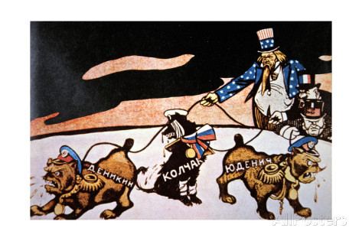

Source 3

The London Evening Standard, March 31st, 1933

FAMINE RULES RUSSIA - The 5-year Plan Has Killed the Bread Supply.
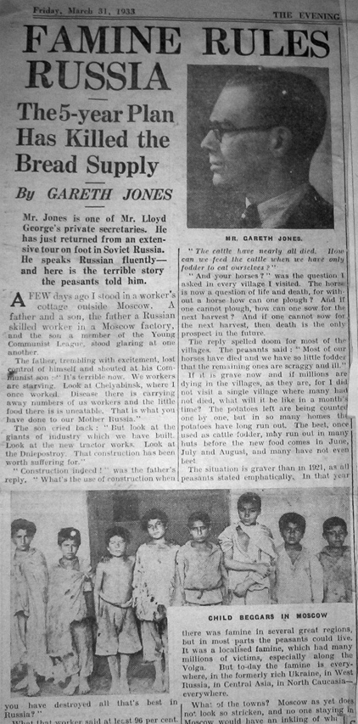
By GARETH JONES.
The Article reads…….
Mr. Jones is one of Mr. Lloyd George’s private secretaries. He has just returned from an extensive tour on foot in Soviet Russia. He speaks Russian fluently - and here is the terrible story the peasants told him.
A few day sago I stood in a worker’s cottage outside Moscow. A father and a son, the father, a Russian skilled worker in a Moscow factory and the son a member of the Young Communist League, stood glaring at one another. The father trembling with excitement, lost control of himself and shouted at his Communist son. It is terrible now. We workers are starving. Look at Chelyabinsk where I once worked. Disease there is carrying away numbers of us workers and the little food there is uneatable. That is what you have done to our Mother Russia.
The son cried back: “But look at the giants of industry which we have built. Look at the new tractor works……. That has construction has been worth suffering for.”
“Construction indeed!” Was the father's reply. “What’s the use of construction when you have destroyed all that’s best in Russia?” What that worker said at least 96 per cent. of the people of Russia are thinking. There has been construction, but, in the act of building, all that was best in Russia has disappeared. The main result of the Five Year Plan has been the tragic ruin of Russian agriculture. This ruin I saw in its grim reality. I tramped through a number of villages in the snow of March. I saw children with swollen bellies. I slept in peasants’ huts, sometimes nine of us in one room. I talked to every peasant I met, and the general conclusion I draw is that the present state of Russian agriculture is already catastrophic but that in a year’s time its condition will have worsened tenfold. What did the peasants say? There was one cry which resounded everywhere I went and that was: “There is no bread.” The other sentence, which as the leitmotiv of my Russian visit was: “All are swollen.” Even within a few miles of Moscow there is no bread left. As I was going through the countryside in that district I chatted to several women who were trudging with empty sacks towards Moscow. They all said: “It is terrible. We have no bread. We have to go all the way to Moscow to get bread and then they will only give us four pounds, which costs three roubles (six shillings nominally). How can a poor man live?”
“Have you potatoes?” I asked. Every peasant I asked nodded negatively with sadness. ………….
“What about your cows?” was the next question. To the Russian peasant the cow means wealth, food and happiness. It is almost the centre-point upon which his life gravitates.
“The cattle have nearly all died. How can we feed the cattle when we have only fodder to eat ourselves?” “And your horses?” was the question I asked in every village I visited. The horse is now a question of life and death, for without a horse how can one plough? And if one cannot plough, how can one sow for the next harvest? And if one cannot sow for the next harvest, then death is the only prospect in the future. The reply spelled doom for most of the villages. The peasants said: “Most of our horses have died and we have so little fodder that the remaining ones all scraggy and ill.” ……….. “It is terrible now” he said. “I get two pounds of bread a day and it is rotten bread. I get no meat, no eggs, no butter. Before the war I used, to get a lot of meat and it was cheap. But I haven’t had meat for a year. Eggs were only a kopeck each before the war, but now they are a great luxury. I get a little soup, but it is not enough to live on.” And now a new dread visits the Russian worker. That is unemployment. In the last few months very many thousands have been dismissed from factories in many parts of the Soviet. Union. I asked one unemployed man what happened to him. He replied: “We are treated like cattle. We are told to get away, and we get no bread card. How can I live? I used to get a pound of bread a day for all my family, but now there is no bread card. I have to leave the city and make my way out into the countryside where there is also no bread.”
The Five-Year Plan has built many fine factories. But it is bread that makes factory wheels go round, and the Five-Year Plan has destroyed the bread-supplier of Russia.

Source 4
Toast to the Russian People at a Reception in Honour of Red Army Commanders Given by the Soviet Government in the Kremlin on Thursday, May 24, 1945

May 24, 1945 – J.V Stalin
COMRADES! Permit me to propose one more, last toast.
I should like to propose a toast to the health of our Soviet people, and in the first place, the Russian people. (Loud and prolonged applause and shouts of “Hurrah.”)
I drink in the first place to the health of the Russian people because it is the most outstanding nation of all the nations forming the Soviet Union.
I propose a toast to the health of the Russian people because it has won in this war universal recognition as the leading force of the Soviet Union among all the peoples of our country.
I propose a toast to the health of the Russian people not only because it is the leading people, but also because it possesses a clear mind, a staunch character, and patience.
Our Government made not a few errors, we experienced at moments a desperate situation in 1941-1942, when our Army was retreating, abandoning our own villages and towns of the Ukraine, Byelorussia, Moldavia, the Leningrad Region, the Baltic area and the Karelo-Finnish Republic, abandoning them because there was no other way out. A different people could have said to the Government: “You have failed to justify our expectations. Go away. We shall install another government which will conclude peace with Germany and assure us a quiet life.” The Russian people, however, did not take this path because it trusted the correctness of the policy of its Government, and it made sacrifices to ensure the rout of Germany. This confidence of the Russian people in the Soviet Government proved to be that decisive force which ensured the historic victory over the enemy of humanity—over fascism.
Thanks to it, to the Russian people, for this confidence!
To the health of the Russian people! (Loud and prolonged applause.)

END OF DOCUMENT SET

Document Set 3: China 1935–1989
Source 1
(From the editor in chief of the Guangming Daily, about the Hundred Flowers Movement, 1957)
After the liberation [1949], intellectuals warmly supported the Party and accepted the leadership of the Party. But in the past few years the relations between the Party and the masses have not been good and have become a problem of our political life that urgently needs readjustment.
Where is the key to the problem? In my opinion, the key lies in the idea that “the world belongs to the Party.” I think a party leading a nation is not the same as a parowning anation; the public supports the Party, but members of the public have not forgotten that they are masters of the nation ... isn’t it too much that within the scope of the nation, there must be a Party man as leader in every unit, big or small, whether section or subsection. ... For many years, the talents or capabilities of many Party men have not matched their duties.

Source 2
(American cartoon on the Great Leap Forward from 1961) 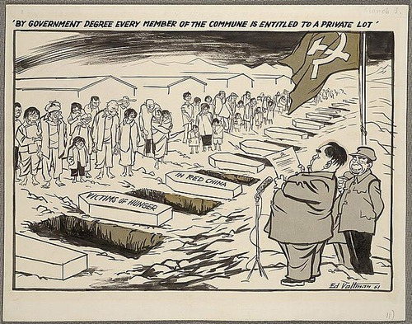

Source 3

China rewrites history of Korean War
On the 60th anniversary of the Korean War, China has finally rewritten its history of how the conflict began to point the finger of responsibility at North Korea.
By Malcolm Moore in Shanghai 11:11AM BST 25 Jun 2010

Until now, the Chinese have staunchly supported their North Korean allies, along whose side they fought in the war.
China previously insisted that the war was waged out of American aggression. The official title of the conflict on the mainland is "The War to Resist America and Aid Korea".
Chinese history textbooks state that the Korean War began when "the United States assembled a United Nations army of 15 countries and defiantly marched across the border and invaded North Korea, spreading the flames of war to our Yalu river."
The official Chinese media stated for the first time that it was North Korea that dealt the first blow. In a special report, Xinhua's International Affairs journal said: "On June 25, 1950, the North Korean army marched over 38th Parallel and started the attack. Three days later, Seoul fell."
China and North Korea were "as close as lips and teeth," said Mao Tse-tung.
The Korean War, which has never formally ended, has been largely forgotten in the West, despite the deaths of between two and three million people in the fighting.
In Asia, however, the memory of the war is still felt strongly and has sustained a continuing alliance and emotional bond between Beijing and Pyongyang.
While many Chinese historians privately subscribe to the view that North Korea was the aggressor in the war, driven by Kim Il-sung's desire to unite the Korean peninsula under a Communist banner, the matter remains highly sensitive.
"It is not convenient for me to comment on the matter," said Zhang Liangui, a leading professor of Korean studies at the Communist Central Party School in Beijing. "I was not aware of this timeline [in the Xinhua article]. As far as I am aware there has been no change to the official view on the war."
Meanwhile, the Global Times, a government-run newspaper, said it was "high time to renew and strengthen efforts by Chinese scholars to discover the truth about the Korean War."
In Seoul, South Korea held an official ceremony to remember the war and Lee Myung-bak, the president, paid tribute to the dead. "Sixty years ago, North Korea's communists opened fire on a weekend's dawn when all people were sleeping peacefully," he said.
Meanwhile, across the border, North Korea put across its own view of the conflict. Under the headline: "US, Provoker of Korean War," the country's state news agency accused Washington of starting the war with a surprise attack.
"All the historical facts show that it is the US imperialists who unleashed the war in Korea and that the United States can never escape from the responsibility," the Korean Central News Agency said.

Source 4
(Extract of a speech by Chairman of the Delegation of the People’s Republic of China, Deng Xiaoping, At the Special Session of the U.N. General Assembly)

Spoken: April, 10, 1974
Mr. President,
The special session of the United Nations General Assembly on the problems of raw materials and development is successfully convened on the proposals of President Houari Boumediene of the Council of Revolution of the Democratic People’s Republic of Algeria and with the support of the great majority of the countries of the world. This is the first time in the 29 years since the founding of the United Nations that a session is held specially to discuss the important question of opposing imperialist exploitation and plunder and effecting a change in international economic relations. This reflects that profound changes have taken place in the international situation. The Chinese Government extends its warm congratulations on the convocation of this session and hopes that it will make a positive contribution to strengthening the unity of the developing countries, safeguarding their national economic rights and interests and promoting the struggle of all peoples against imperialism, and particularly against hegemonism.
At present, the international situation is most favourable to the developing countries and the peoples of the world. More and more, the old order based on colonialism, imperialism and hegemonism is being undermined and shaken to its foundations. International relations are changing drastically. The whole world is in turbulence and unrest. The situation is one of “great disorder under heaven,” as we Chinese put it. This “disorder” is a manifestation of the sharpening of all the basic contradictions in the contemporary world. It is accelerating the disintegration and decline of the decadent reactionary forces and stimulating the awakening and growth of the new emerging forces of the people.
In this situation of “great disorder under heaven,” all the political forces in the world have undergone drastic division and realignment through prolonged trials of strength and struggle. A large number of Asian, African and Latin American countries have achieved independence one after another and they are playing an ever greater role in international affairs. As a result of the emergence of social-imperialism, the socialist camp which existed for a time after World War II is no longer in existence. Owing to the law of the uneven development of capitalism, the Western imperialist bloc, too, is disintegrating. Judging from the changes in international relations, the world today actually consists of three parts, or three worlds, that are both interconnected and in contradiction to one another. The United States and the Soviet Union make up the First World. The developing countries in Asia, Africa, Latin America and other regions make up the Third World. The developed countries between the two make up the Second World.
The two superpowers, the United States and the Soviet Union, are vainly seeking world hegemony. Each in its own way attempts to bring the developing countries of Asia, Africa and Latin America under its control and, at the same time, to bully the developed countries that are not their match in strength………

END OF DOCUMENT SET

Document Set 4: The changing European world since 1945
Source 1
In March 1983, US president Ronald Reagan delivered an address to evangelical Christians in Orlando, Florida, referring to the Soviet Union as an “evil empire”:

“I intend to do everything I can to persuade [the Soviet Union] of our peaceful intent, to remind them that it was the West that refused to use its nuclear monopoly in the forties and fifties for territorial gain and which now proposes 50 percent cut in strategic ballistic missiles and the elimination of an entire class of land-based, intermediate-range nuclear missiles.
At the same time, however, they must be made to understand we will never compromise our principles and standards. We will never give away our freedom. We will never abandon our belief in God. And we will never stop searching for a genuine peace. But we can assure none of these things America stands for through the so-called nuclear freeze solutions proposed by some…
A number of years ago, I heard a young father, a very prominent young man in the entertainment world, addressing a tremendous gathering in California. It was during the time of the cold war, and communism and our own way of life were very much on people’s minds. And he was speaking to that subject. And suddenly, though, I heard him saying, ‘I love my little girls more than anything’. And I said to myself, ‘Oh, no, don’t. You can’t—don’t say that’. But I had underestimated him. He went on: ‘I would rather see my little girls die now, still believing in God, than have them grow up under communism and one day die no longer believing in God’.
There were thousands of young people in that audience. They came to their feet with shouts of joy. They had instantly recognised the profound truth in what he had said, with regard to the physical and the soul and what was truly important.
Yes, let us pray for the salvation of all of those who live in that totalitarian darkness—pray they will discover the joy of knowing God. But until they do, let us be aware that while they preach the supremacy of the state, declare its omnipotence over individual man, and predict its eventual domination of all peoples on the Earth, they are the focus of evil in the modern world.
……. if history teaches anything, it teaches that simple-minded appeasement or wishful thinking about our adversaries is folly. It means the betrayal of our past, the squandering of our freedom.
So, I urge you to speak out against those who would place the United States in a position of military and moral inferiority… I urge you to beware the temptation of pride—the temptation of blithely declaring yourselves above it all and label both sides equally at fault, to ignore the facts of history and the aggressive impulses of an evil empire, to simply call the arms race a giant misunderstanding and thereby remove yourself from the struggle between right and wrong and good and evil.”

Source 2
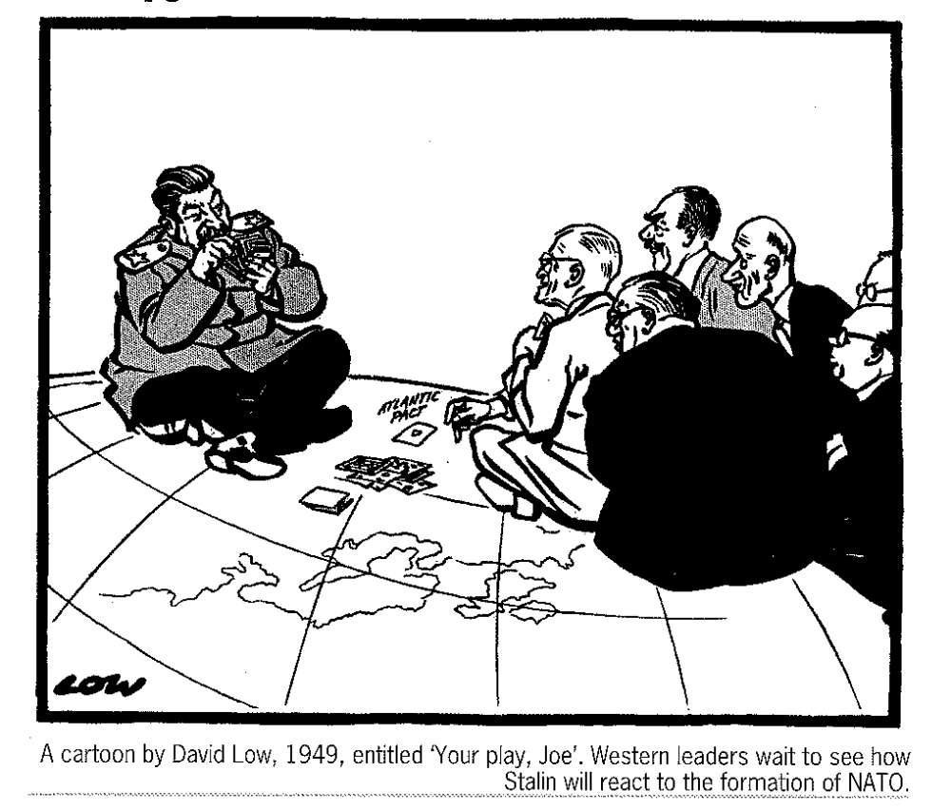

Source 3
In April 1957, US Secretary of State John Foster Dulles addressed journalists in New York and spoke on a number of Cold War issues and policies:
…“Communism in practice has proved to be oppressive, reactionary, unimaginative. Its despotism, far from being revolutionary, is as old as history. Those subject to it, in vast majority, hate the system and yearn for a free society.
The question of how the United States should deal with this matter is not easily answered. Our history, however, offers us a guide. The United States came into being when much of the world was ruled by alien despots. That was a fact we hoped to change. We wanted our example to stimulate liberating forces throughout the world and create a climate in which despotism would shrink. In fact, we did just that…
Let us also make apparent to the Soviet rulers our real purpose. We condemn and oppose their imperialism. We seek the liberation of the captive nations. We seek this, however, not in order to encircle Russia with hostile forces but because peace is in jeopardy and freedom a word of mockery until the divided nations are reunited and the captive nations are set free.”

Source 4
In September 1960 Soviet leader Nikita Khrushchev addressed the United Nations general assembly, touching briefly on the American U2 spy plane controversy weeks before:

“Our century is the century of the struggle for freedom, the century in which nations are liberating themselves from foreign domination. The peoples desire a worthwhile life and are fighting to secure it. Victory has already been won in many countries and lands. But we cannot rest on our laurels, for we know that tens of millions of human beings are still languishing in colonial slavery and are suffering grave hardships…
We saw a dangerous manifestation of the work of these forces last spring when the aircraft of one of the largest member states of the United Nations, the United States of America, treacherously invaded the airspace of the Soviet Union and that of other states. What is more, the United States has elevated such violations of international law into a principle of deliberate state policy.
The aggressive intrusion into our country by a United States aircraft, and the whole course of the United States government’s subsequent behaviour, showed the peoples that they were dealing with a calculated policy on the part of the United States Government, which was trying to substitute brigandage for international law, and treachery for honest negotiations between sovereign and equal states.
The flights by the United States’ spy aircraft are also instructive in another respect. They have shown up the danger to peace presented by the network of United States bases in which dozens of states in Europe, Asia, Africa and Latin America are enmeshed. Like a deep-seated form of acute infection in a living organism, these bases disrupt the normal political and economic life of the states upon which they have been foisted. They hinder the establishment of normal relations between those states and their neighbours.
How can there be any question of normal relations if the people of these neighbouring countries cannot sleep peacefully, if they have to live with the threat of being subjected to an annihilating blow whenever the United States militarists take it into their heads to embark on fresh acts of provocation?”

END OF DOCUMENT SET
Document Set 5: Australia’s engagement with Asia
Source 1
(Extract of Robert Menzies Election Speech The election was held on 28 April, 1951. Menzies made protecting the nation against the threat of Communism the major theme of the election campaign. He constantly accused the Labor Party of being soft on Communism and Labor Party members of cooperating through union activity with Communist Party members.

The Korean War encouraged Menzies determination to ban the Communist Party. In 1950 the ‘Communist Party Dissolution’ bill was introduced into Parliament.)

……..I will in the course of this speech have much to say about the damage which Communism does to industry and production. But tremendously important as this is. it is a symptom only. The real disease of Communism is deeper and more deadly, and unless we attack it by all possible means, it will infect the whole of our community life.
The industrial activities of the Communists prove them to be destructive and disloyal, a fifth column for a potential enemy. Why should Communists do these things? The answer is that Communism is a materialistic doctrine, void of spiritual content. It is not only anti-Christian, but is opposed to all those nobler aspirations which spring from the religious faith of decent people. True, Communism itself has been called, by some, a religion. But it is a religion of hatred; it derives from the darkest recesses of the human mind; it has nothing in common with the Christian gospel of love and brotherhood. If it had, it could not preach the class war or use envy and malice as its characteristic weapons.
In this great and free country of ours we have at least learned that hatred of other men is no instrument of progress but is merely a sign of decadence and despair.
When, therefore, I say to you that the Government is pledged to make war upon Communism I am not talking about an attack upon individuals as such (though we are determined to root out key Communists from key positions), but upon a set of evil ideas which are quite foreign to our civilisation, our traditions, and our faith.
Those who persist, as does the Leader of the Opposition, in regarding Communism as just some variant of democratic political philosophy entirely overlook the fact that Communism is debased, treasonable, utterly undemocratic; in form a subversive conspiracy; in practice opposed to high standards of living and real prosperity; destructive, if it succeeds, of all human freedom.

We are pledged to fight it, and to defeat it…….

Source 2
Draft Resisters Union, March 20–25: anti- draft week (1971, screen print on coloured paper, 45.8 x 29.2 cm, ARTV03064)

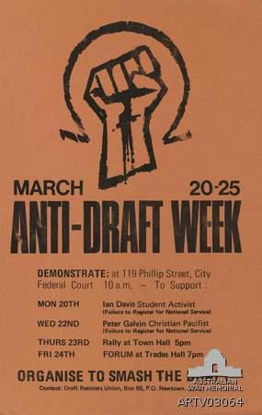

Source 3

(Archival article from The Melbourne Age newspaper in relation to the conflict in Timor - 5 December 1977, page 29, quoting then Yugoslav diplomat Dr Georgi Trajkovski.)

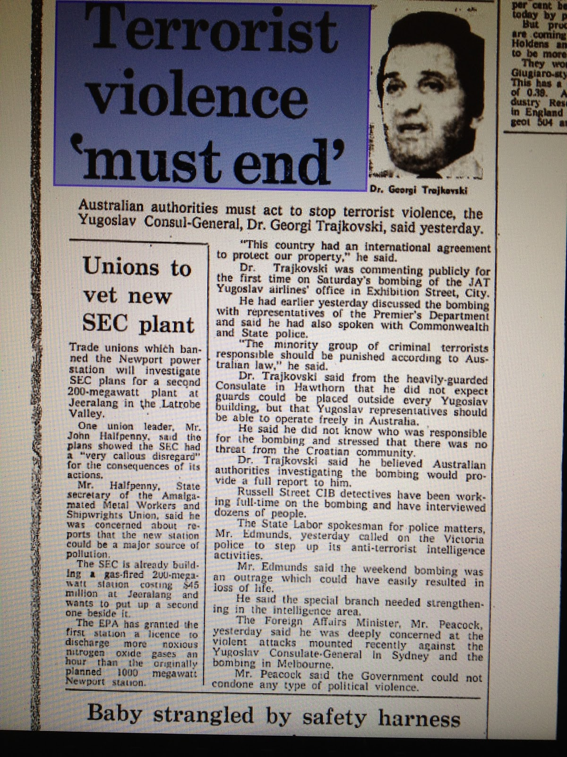

Source 4
(An extract from Australian Multiculturalism: the roots of its success
Dr Sev Ozdowski OAM Director, Equity and Diversity, University of Western Sydney
Third International Conference on Human Rights Education: Promoting Change in Times of Transition and Crisis. The Jagiellonian University in Krakow, Poland, 6-10 December 2012)

The post war migration started with a preference for ‘ten pound’ British immigrants; however, when the number of British migrants fell short of what was required Arthur Calwell, opened Australia’s immigration to the hundreds of thousands of people displaced by the War from Central Europe and then Southern Europe. The Menzies Government (1949-66) continued the immigration program that the Chifley Labor government had started and signed the Refugee Convention in 1954. By late 1960s, European migration had slowed and it was no longer sufficient to support Australian appetite for population growth.
Mass migration required changes to immigration and related laws. The division between the British and non-British Australians and the ‘White Australia’ policy were not only out of date with modern Australia and her needs for more migrants, but also offensive to a growing proportion of Australians and to Australia’s neighbours. A change was imminent. As many new arrivals were not British subjects, Australian citizenship was created by the Nationality and Citizenship Act 1948. It was also a time to dismantle the ‘White Australia’ policy and introduce a program of global non-discriminatory immigration intake.
But it took some 25 years to completely dismantle the ‘White Australia’ laws and associated practices. The process was started in 1949 by the Menzies Government allowing some 800 non-European refugees to remain in Australia and allowing Japanese war brides to enter Australia. In May 1958, the Menzies Government replaced the arbitrarily applied dictation test with an entry permit system, that reflected economic and skills criteria. In 1960 the term ‘White Australia’ was removed from the Liberal Party’s Federal Policy Platform and the Labor Party followed five years later. The final vestiges were removed in 1973 by the Whitlam Labor government and the migration from non-European countries started after the Fraser government came into office in 1975.
The abolition of White Australia Policy and the resulting globalisation of immigration and refugee intake led to a significant increase in immigration from Asian and other non-European countries. The breakthrough came in August 1977 when, with the European migration being unable to deliver the numbers Australia needed, the Fraser government
started significant intake from South-East Asia.
Now Australia has a non-discriminatory global immigration intake based on skills. For example, of total immigration intake of 127,460 between July 2010 and June 2011, 15.5% migrants came from China and 8.3% migrants arrived from India. In addition, Australia has a generous refugee intake program of some 20,000 people per year.

END OF DOCUMENT SET

Document Set 6: The struggle for peace in the Middle East
Source 1

(Direct quote from June 14, 1967 - Abba Eban TV broadcast (Booklet published 1992, Zionist Federation, Rex House, SW1)
"Wars are not always begun by shots. They are often begun by action and the action which really created the state of war in an acute sense was the imposition of the blockade. To try to murder somebody by strangulation is just as much attempted murder as if you tried to murder him by a shot, and therefore the act of strangulation was the first violent, physical act which had its part in the sequence. But also on that Monday morning we acted against the movement of forces. The Egyptian air force had been making incursions into Israel before, whether for reconnaissance or for other reasons, but there had been a pattern of encroachment. One never knows when aircraft come towards you what their intention is.

A document which we subsequently captured revealed a very instructive picture. The Egyptian command was taking a very intense interest in the disposition of Israel's very few airfields. They wanted to know where they were, and there was an operation plan, which I read to the Security Council, about how to knock them out. My impression is, therefore, that those aircraft which appeared on our radar screens that Monday morning were the start of an operation against our air fields. Whether they were to make the first reconnaissance move or the first knock-out is not relevant in this era of war. But we acted against movement towards us in the air."
Source 2

(On 28 September 1978, after the conclusion of the Middle-East peace agreements at Camp David (Maryland), the cartoonist Fritz Behrendt depicts the decisive action of US President, Jimmy Carter.)
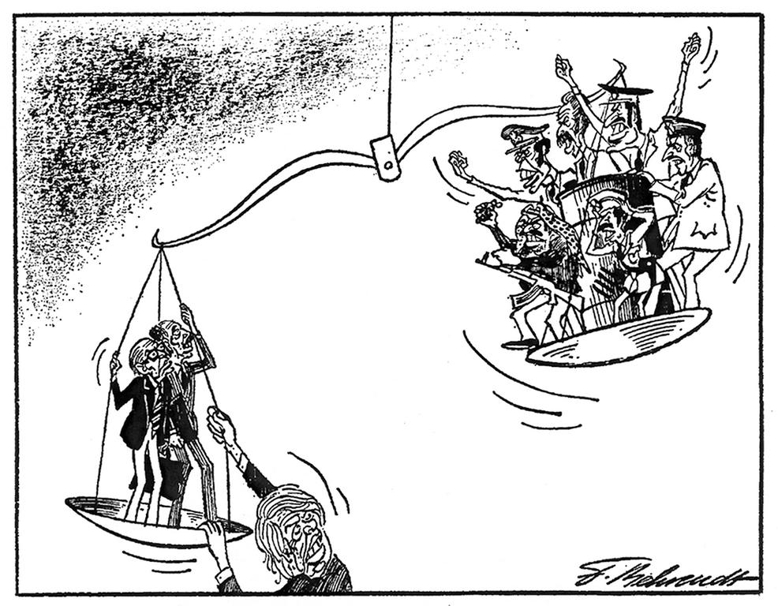

Source 3
The 1991 Persian Gulf War, October 20, 2004; Page A08 – Washington Post, Lucian Perkins

When Kerry rose in the Senate to oppose authorization for war against Iraq in January 1991, his words conveyed a wary, Vietnam-haunted approach to the use of military force that contrasted sharply with his vote a decade later to go to war a second time against Iraq. He was on the losing side of the vote on that war, which turned out to be far less costly in human and financial terms than Kerry and most Democrats -- 45 of the party's 54 senators opposed it -- predicted.

In a lengthy speech, Kerry touched on most of the arguments that other critics made against going to war: Sanctions had not been given enough time to work; the American people were not prepared for the heavy casualties that might result; the war might spawn further instability in the Middle East. But it was Vietnam -- especially fighting a war that did not have the full backing of the American people -- that appeared to influence Kerry as much as anything else.
"The question of being ready and certain is important to many of us of the Vietnam generation," Kerry said. "We come to this debate with a measure of distrust, with some skepticism, with a searing commitment to ask honest questions and with a resolve to get satisfactory answers so that we are not misled again."
Kerry said he was "willing to accept the horror that goes with war" but only "when the interests or stakes warrant it." He added: "My belief is, though, that our impatience with sanctions and diplomacy does not yet warrant accepting that horror, and my fear is that our beloved country is not yet ready for what it will witness and bear if we go to war."
Kerry concluded by reading from a novel by Dalton Trumbo on the eve of World War II about a horribly mutilated young soldier who wanted to put himself on display before the world's statesmen to remind them of the costs of war. "That is the only issue before this body," Kerry said.

Kerry has never backed away from his opposition to the war, an aide said.

Source 4
The role of the United Nations in Middle East conflict prevention.
Report from Center on International Cooperation Published on 06 Jul 2009, by Elizabeth Sellwood

Conflicts in the Middle East are of strategic, economic and religious importance to the world's most powerful states. For centuries the region has been at the centre of struggles for religious and economic dominance. In the past decade alone, both the United States and the European Union have invested immense political capital and many billions of dollars in efforts to transform the political and security dynamics of the Middle East.
A number of United Nations peacekeeping and political missions are deployed in this region.1 These missions are mandated by the Security Council to help maintain truces and ceasefires, to report to the Security Council on the actions of the parties, and to employ the Secretary-General's good offices to promote peace, security and the resolution of conflicts. These missions are generally well-resourced and enjoy the political support of member states; but despite these strengths the United Nations is not a powerful political actor in the Middle East. UN missions have no capacity to force recalcitrant parties to take particular courses of action, and cannot by themselves provide financial support or security guarantees. In this tough region, a Security Council Resolution or an intervention by the Secretary-General has less impact than it does in other less politically crowded and strategically important contexts. For this reason, the UN's record in Middle East conflict prevention is in some ways less than impressive: the Organisation has been powerless to enforce numerous Security Council resolutions calling for "Withdrawal of Israeli armed forces from territories occupied" in the 1967 war, "a just settlement of the refugee problem,"2 and for implementation of the Tenet Work Plan, the Mitchell Report recommendations3 and the Roadmap.4 It was unable to

stop Israeli attacks on Gaza in early 2009, or force Iran to comply with resolutions relating to its nuclear activities. And the UN could not prevent the "illegal" US invasion of Iraq in 2003.5
The UN's reputation has certainly been damaged by the "gap", as one Arab diplomat put it, "between what the Organisation promises and its ability to make a difference on the ground."6 But while UN missions lack hard enforcement power, the Organisation does have immense scope to intervene in more subtle ways in the Middle East. The UN Security Council, often operating with advice or guidance from the Secretary-General, has a unique capacity to provide legal endorsement and legitimise particular courses of action: to endorse international borders, or to certify (or deny) that an occupation has ended. United Nations political envoys operate under broad mandates and routinely interact with a range of regional parties, often with the support of powerful member states. Meanwhile, UN peacekeeping, humanitarian and political officers are based in the region's most complex and sensitive areas, often in places that are inaccessible to other international actors. Many UN officials have been in post for several years and speak relevant languages. They have regular access to government and security officials, professionals and civil servants, militia leaders, religious authorities, refugees, and thousands of ordinary families. Through these contacts, and via this range of operations, the UN can open doors, initiate discussions, and cross borders in ways that are impossible for many other actors.
United Nations political and peacekeeping missions can deploy their tools most effectively when they are supported by powerful UN member states. The Organisation can be paralysed when there is no consensus among Security Council members. In Middle East peacemaking, the approach adopted by the US has long been of particular importance. We have recently witnessed important changes in the US approach: the Obama foreign policy team have indicated that they wish to work more systematically with international partners, and to adopt a multilateral approach where possible. The US has already made clear its intention to work closely with the UN as it withdraws from Iraq. The new tone adopted by the US Government has already helped to strengthen consensus in international policy coordination bodies such as the Quartet.
This growing international policy consensus regarding conflicts and security threats in the Middle East may enable UN missions in the region to operate increasingly effectively on the basis of their existing mandates. There may, in the coming years, be an increasing international appetite for the UN to take on additional conflict prevention tasks. To use the UN's tools to greatest effect, policy makers inside and beyond the UN need to understand what the Organisation can and cannot do to help prevent conflict in the Middle East.

END OF DOCUMENT BOOKLET

ACKNOWLEDGEMENTS

Document Set One Australia 1918–1955

Source 1 Australia, National Archives of. (2016). William Morris Hughes In Office. Retrieved June 6, 2016, from Australia's Prime Ministers: http://primeministers.naa.gov.au/primeministers/hughes/in-office.aspx
Source 2 National Archives of Australia. (2010). 'A sister to assist her' – assisted migration cartoon. (E. S. Ltd, Editor) Retrieved June 6, 2016, from VRROOM Virtual Reading Room: http://vrroom.naa.gov.au/print/?ID=19452

Source 3 National Archives of Australia. (2016). Robert Menzies In Office. (C. o. Australia, Editor) Retrieved June 6, 2016, from Australian Prime Ministers: http://primeministers.naa.gov.au/primeministers/menzies/in-office.aspx

Source 4 Office of the Historian, Bureau of Public Affairs. (2016). The Australia, New Zealand and United States Security Treaty (ANZUS Treaty), 1951. (U. S. State, Editor) Retrieved June 6, 2016, from Office of the Historian: https://history.state.gov/milestones/1945-1952/anzus

Document Set Two Russia and the Soviet Union 1914–1945

Source 1 Stalin, J. V. (1925). SPEECH DELIVERED AT A PLENUM OF THE CENTRAL COMMITTEE AND THE CENTRAL CONTROL COMMISSION OF THE R.C.P.(B.) (From J. V. Stalin, On the Opposition, Foreign Languages Press, Peking, 1974 ed., Vol. 7). (Prepared © for the Internet by David J. Romagnolo, Ed.) Moscow, Russia: From J. V. Stalin, On the Opposition, Foreign Languages Press, Peking, 1974.

Source 2 AllPosters. (2016). Bolshevik Cartoon on the Intervention of the Usa, Britain and France in the Russian Civil War, 1919. Retrieved june 6, 2016, from AllPosters.com: http://www.allposters.com/-sp/Bolshevik-Cartoon-on-the-Intervention-of-the-Usa-Britain-and-France-in-the-Russian-Civil-War-1919-Posters_i12155550_.htm?stp=true

Source 3 Jones, G. (1933, March 31). FAMINE RULES RUSSIA. The 5-year Plan Has Killed the Bread Supply. Retrieved June 6, 2016, from http://www.colley.co.uk/garethjones/soviet_articles/famine_rules_russia.htm

Source 4 Stalin, J. V. (1945, May 24). Toast to the Russian People at a Reception in Honour of Red Army Commanders Given by the Soviet Government in the Kremlin on Thursday, May 24, 1945. Retrieved June 6, 2016, from Maxists.org: https://www.marxists.org/reference/archive/stalin/works/1945/05/24.htm

Document Set Three China 1935–1989

Source 1 Asia for Educators. (1957). INTELLECTUAL OPINIONS FROM THE HUNDRED FLOWERS PERIOD. http://afe.easia.columbia.edu, Primary Source Document with Questions (DBQs). Columbia: Columbia University.

Source 2 Everyday Life in Mao's China. (2016, March 25). American cartoon on the great Leap Forward from 1961. Retrieved June 6, 2016, from Everyday Life in Mao's China: https://everydaylifeinmaoschina.org/2016/03/25/american-cartoon-on-the-great-leap-forward-from-1961/

Source 3 Moore, M. (2010, June 25). China rewrites history of Korean War. The Telegraph . Shanghai, China: http://www.telegraph.co.uk/news/worldnews/asia/southkorea/7853746/China-rewrites-history-of-Korean-War.html.

Source 4 Xiaoping, D. (1974, April 10). Speech By Chairman of the Delegation of the People’s Republic of China, Deng Xiaoping, At the Special Session of the U.N. General Assembly. Foreign Languages Press . (C. Liebl, Trans.) New York, USA: https://www.marxists.org/reference/archive/deng-xiaoping/1974/04/10.htm.

Document Set Four The changing European world since 1945

Source 1 Doone, B et al, Alpha History, The Cold War, https://alphahistory.com/coldwar/ronald-reagan-evil-empire/ retrieved 12/09/18

Source 2 Walsh, B. GCSE Modern World History, second edition. John Murray publishers, (2001)

Source 3 Doone, B et al, Alpha History, The Cold War, https://alphahistory.com/coldwar/john-foster-dulles-speech-1957/ retrieved 12/09/18

Source 4 Doone, B et al, Alpha History, The Cold War, https://alphahistory.com/coldwar/khrushchev-un-u2-spyplane-1960/ retrieved 12/09/18

Document Set Five Australia’s engagement with Asia

Source 1 Menzies, R. (1951, April 28). Election Speeches. Retrieved June 6, 2016, from Australian Federal Election Speeches: http://electionspeeches.moadoph.gov.au/speeches/1951-robert-menzies

Source 2 Australian War Memorial. (1971, March 20-25). Recruitment and propaganda. Retrieved June 6, 2016, from Australian War Memorial: https://www.awm.gov.au/sites/default/files/activity-recruitment.pdf

Source 3 Uzunov, S. (2012, July 16). ASIO WITHDRAWS SPY FILE. Retrieved June 6, 2016, from Team Uzunov: http://teamuzunovmedia.blogspot.com.au/2012/07/asio-withdraw-spy-file.html

Source 4 Ozdowski, S. (2012, December 6-10). Australian Multiculturalism: the roots of its success. (E. a. Director, Producer) Retrieved June 6, 2016, from Equity and Diversity: https://www.uws.edu.au/equity_diversity/equity_and_diversity/tools_and_resources/reportsandpubs/australian_multiculturalism_the_roots_of_its_success

Document Set Six The struggle for peace in the Middle East
Source 1 Six Day War. (2007). 6 Days War: Crucial quotes. Retrieved June 6, 2016, from Six Day War : http://www.sixdaywar.co.uk/crucial_quotes.htm

Source 2 C VCE Innovating European Studies. (2004). Cartoon by Behrendt on the Camp David Accords (28 September 1978). (L. G.-D. Luxembourg, Producer) Retrieved June 6, 2016, from CVEE: http://www.cvce.eu/en/obj/cartoon_by_behrendt_on_the_camp_david_accords_28_september_1978-en-185c0da7-e22e-4ec1-a77d-270e2d22c313.html

Source 3 The Washington Post. (2004, Ocotber 8). The 1991 Persian Gulf War. Retrieved June 6, 2016, from The Washington Post: http://www.washingtonpost.com/wp-dyn/articles/A46340-2004Oct19.html

Source 4 Sellwood, E. (2009, July 6). The role of the United Nations in Middle East conflict prevention. Retrieved June 6, 2016, from REPORTfrom Center on International Cooperation: http://reliefweb.int/report/iraq/role-united-nations-middle-east-conflict-prevention

